DON’T LEAVE
MONEY
ON THE TABLE!
Attend a free AAUW Work Smart
Salary Negotiation Workshop

Date: September 28, 2019
Time: 1:00 PM to 3:30 PM
Hosted by: St. Paul Branch of
American Association of University Women (AAUW)

Location: Highland Park Library
1974 Ford Pkwy, Saint Paul, MN 55116
Parking lot and on street parking nearby
Public Transportation Available

Registration required by September 25,
email to : alta.oben@gmail.com Subject: Work Smart
Include your name, email address, and phone number
**If you need supervised child reading/activity, please indicate so and give ages of children (May be a small charge)
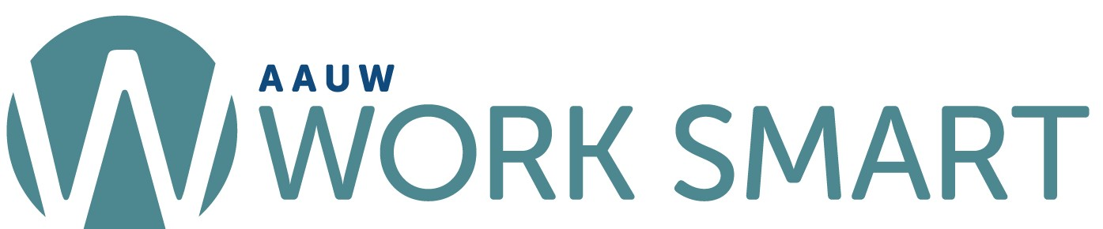
Public Transportation on Green Line and Metro A Line
Library Walking Distance from Ford Parkway and Kenneth Stop
